Ideation Phase
Define the Problem Statements
Date | 10 July 2026
Team ID | Geeta Rani
Project Name | ShopEZ
Maximum Marks | 2 Marks

Customer Problem Statement Template
The Customer Problem Statement template has been used to highlight and analyze various problems experienced by different users of ShopEZ. PS-1: In PS-1, a shopper looking for a fast and reliable way to browse and purchase products online was identified. The shopper would like to view a clean product catalog and complete a purchase without navigating a cluttered or slow interface. PS-2: In PS-2, a returning customer managing a shopping cart across multiple visits was identified. The customer requires a persistent, secure account so that cart items and order activity are not lost between sessions.

Problem Statement 1

Problem Statement 2
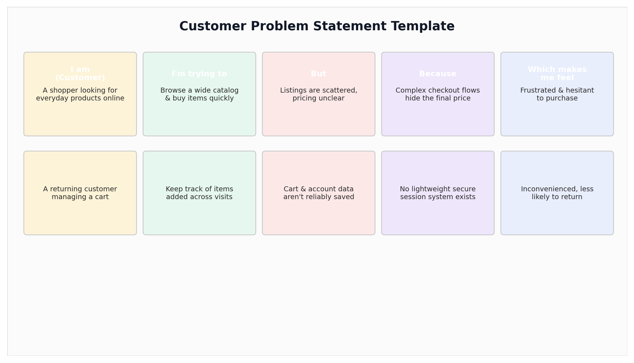

Example:
Problem  Statement (PS) | I am  (Customer) | I'm trying to | But | Because | Which makes  me feel
PS-1 | A shopper looking for everyday products online. | Browse a wide catalog and buy items quickly. | Product listings are scattered and pricing is unclear. | Many stores require account creation and complex checkout flows before showing a final price. | Frustrated and hesitant to complete a purchase.
PS-2 | A returning customer managing a shopping cart. | Keep track of items I've added and check out later. | Cart data and account details are not reliably saved. | There is no lightweight, secure system to persist a session across visits. | Inconvenienced and less likely to return.

